Korean Pharmaceutical Companies

◇ ChongKunDang Pharmaceutical
◇ Green Cross
◇ Hanmi Pharmaceutical
◇ Kolon Life Science
◇ MediPost
◇ Macrogen
◇ Viromed
◇ Boryung Pharmaceutical

Daewoong Pharmaceutical, a global healthcare group that was established in 1945, carries a conviction of maintaining people’s health and making a healthy society by supplying high-quality medicines. With the management based on principles and transparency, Daewoong has been growing with the positive net income since it went public in 1973.
Daewoong is one of the top leading pharmaceutical companies in Korea and is positioning #1 in prescription drug sales. Each of Daewoong’s major products (i.e. URSA) records its sales amount of more than $10 million USD, making Daewoong a leading company in the pharmaceutical industry.
We strictly pursue the quality principle of ‘no compromise’ and make our best effort to always provide the high-quality medicinal products and services to our customers. In terms of the development of new drugs, we have been increasing the global R&D capabilities by establishing research centers in India, China, and the United States.
In virtue of our major products including URSA, Daewoong’s growth potential was recognized and for the first time in Korean pharmaceutical industry, we were selected for the ‘World Class 300 project’ in 2012, a government supported global business development project. We were also selected as ‘Innovative Pharmaceutical Company’ by the government in 2012, for investing more than 10% of our sales into R&D.
◦ Product Portfolio
No | Classifi-  cation | Section  (Bio/Synthesis) | Product Name | Main Ingredient | Use  (Indications) | Formulation | Date of Sales
1 | IMD | Comb. | Olostar | Olmesartan  Rosuvastatin | Hypertension  Dyslipidemia | Tablet | 2014
2 | Bio-similar | Bio | Eposis | Erythropoietin | anemia | Injection
3 | Bio-similar | Bio | Caretropin | Somatropin | growth hormone deficiency | Injection
4 | Bio | Bio | Nabota | Botulinum toxin type A | glabellar lines | Injection | 2014
5 | NCE | Bio | Easyef | Epidermal growth factor | diabetic foot ulder | Spray | 2001
6 | NCE | Comb. | URSA | Ursodeoxycholic acid (UDCA) | Liver disease | Tablet/  Capsule | 1986
7 | IMD | Comb. | Albis | Ranitidine  Bismuth  Sucralfate | Gastroenterology | Tablet | 2000
8 | IMD | Comb. | Smecta | Dioctahedral smectite | Diarrhea | Suspension
9 | Branded  Generic | Comb. | Luphere | Leuprolide acetate | prostate cancer, endometriosis, breast cancer | Injection | 2005

◦ R&D Pipeline
No | Classifi-  cation | Section  (Bio/Synthesis) | Name of Technology | Main Ingredient  (Description) | Use  (Indications) | Stage of Development
1 | IMD | Small Molecule | CV Fixed-dose Combination | Chemical | Hyperlipidemia/ Hypertension | Approved
2 | Bio-similar | Bio | Recombinant human erythropoietin α | Bio | Anemia of CRF | Marketed
3 | Bio-similar | Bio | Recombinant human growth hormone | Bio | Deficiency of HGH | Marketed
4 | New Drug | Biologics | Epidermal Growth Factor | EGF | Diabetic Foot Ulcer | Marketed
5 | Bio convergence | Others | Alveolar Bone Regeneration | BMP-2 | Bone Formation | Approved
6 | Bio convergence | Others | Spinal Fusion | BMP-2 | Bone Formation | Phase III
7 | IMD | Small Molecule | Nurigra Chewable Tablet | Sildenafil Citrate | Erectile Dysfunction | Marketed
8 | IMD | Small Molecule | MEGAVEC  400MG | Imatinib | Leukemia | Marketed
9 | Branded Generic | Semi Synthesis | UDCA High Purity | Ursodeoxycholic Acid | PBC | Marketed
10 | Branded Generic | Small Molecule | Sustained Release of Leuprolide | Leuprolide Acetate | Cancer | Marketed

◦ GMP Certifications
No | Product Name | Active Ingredient | Indication | Status
1 | Eposis | Recombinant human erythropoietin α | Anemia of CRF | Certified: Vietnam, Philippines, Thailand/  Ongoing: Sri Lanka, Turkey
2 | Caretropin | Somatropin | Deficiency of HGH | Certified: Vietnam/  Ongoing: Ukraine, Iran, Uruguay, Philippines, Indonesia, Thailand, Pakistan
3 | Ursa | Ursodeoxycholic Acid | PBC/Gallstone | Certified: Vietnam, Thailand, Philippines,
4 | Ursa | Ursodeoxycholic Acid | Liver Function Disorder | SFDA
5 | Luphere/Leuprogene | Leuprolide | Prostate Cancer  Endometriosis | Certified: Vietnam, Philippines, Nigeria  Ongoing: Russia Minzdrav Authoriazation, Mexico, Thailand
6 | Meropenem | Meropenem | Antibioti20/5 tabs | ANDA
7 | Olosta | Olmesartan  /Rosuvastatin | Hypertension /Hyperlipidemia | Ongoing registration for SFDA Approval
8 | Nabota | Clostridium Botulinum Toxin A | Glabbler Line | Ongoing registration for Thailand Approval
9 | Easyef | Nepidermin | Diabetic Foot Ulcer | Authorization Vietnam, Thailand, Ongoing registration more than 20 coutries including Turkey, Russia
◦ Contact Information
Name | Eunsun Yang
Position | Manager
Email | esyang365@daewoong.co.kr
Phone | 82-2-550-8452

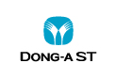

Company | Dong-A ST(Science & Technology)
Representative | Chan-il Park | E-mail | cipark@donga.co.kr
Representative  Phone No. | +82-2-920-8114 | Representative Fax No. | +82-2-926-9400
Hompage | htttp://en.donga-st.com
Address | 64, Cheonho-daero, Dongdaemun-gu, Seoul, Korea
Research Institute Address | 21, Geumwha-ro, 105 beon-gil, Giheung-gu, Yongin-si, Gyeonggi-do, Korea
Year of Establishment | 2013 | Sales (‘14) | KPW 56,810Million
The Number of Employees (‘14) | Total | The Number of Researcher (‘14) | Total
 | 1,582 |  | 212
Contact Person | Geunsung Kim | Contact Phone | +82-2-920-8366
Contact E-mail | e2110576@donga.co.kr | Contact Fax | +82-2-924-2662
Introduction of Company
Dong-A Pharmaceutical Co. Ltd. was founded under the name of ‘Joong-hee Kang’s Wholesaler’ which is a wholesale business for medicines and hygienic materials in 1932. Since 1967, it has steadfastly maintained the No.1 position in the Korean pharmaceutical industry by focusing on Bacchus (an energy drink), medicines, and various medical supplies with its competitive marketing capabilities and nation-wide sales networks.
In a bid to go global, Dong-A Pharmaceutical Co. Ltd. has shifted to a holding company structure in 2013 and has made a new start to become a global healthcare company. It has divided into Dong-A Socio Holdings, (new)Dong-A Pharmaceutical, and Dong-A ST(Science Technology).
Dong-A Socio Holdings pushes to secure growth engines through the development of biomedicines and innovative drugs, and to expand businesses from pharmaceuticals to medical services and new businesses. With Dong-A Socio Holdings taking overall control, Dong-A ST engages in the ethical-drug business while Dong-A Pharmaceutical Company engages primarily in over-the-counter products.
Dong-A ST focuses on drugs, such as domestically developed new drugs like Stillen, Zydena, and Motilitone, medical devices, diagnosis, and overseas businesses.
With its optimized research infrastructures such as its world-class, sophisticated research center completed in 2011, as well as its excellent researchers, Dong-A ST is furthering its efforts to develop global new drugs. Also, with the backing of these infrastructures, Dong-A ST vows to positively explore overseas markets, to expand its overseas exports, and to establish itself as a global pharmaceutical 0company, operating beyond the domestic market.

No. | Classification | Bio, Synthesis | The Name of Products | Main Ingredient | Use (Indications) | Formulation
1 | Phytomedicine | Extracted | Stillen | artemisia argyi folium extract 95% ethanol 60mg | Gastritis | Tablet
2 | NCE | Synthesis | Zydena | Udenafil | Erectile Dysfunction | Tablet
3 | Phytomedicine | Extracted | Motilitone | Corydalis tuber, Pharbitis seed (5:1) extract 50% ethanol 30mg | Functional dyspepsia | Tablet
4 | IMD | Synthesis | Orodipine | Amlodipine orotate | Hypertension | Tablet
5 | IMD | Synthesis | Orosartan | Valsartan & Amlodipine orotate | Hypertension | Tablet
6 | Generic drug | Synthesis | Lipinon | Atorvastatin | Dyslipidemia | Tablet
7 | Generic drug | Synthesis | Plavitor | Clopidogrel | Atherosclerosis | Tablet
8 | Generic drug | Synthesis | Glimel | Glimepiride | Diabetes | Tablet
9 | Generic drug | Bio | Monotaxel | Docetaxel | Anti-Malignant Tumor Drug | Injection
10 | Biopharmaceutical  Products | Bio | Growtropin  Ⅱ inj. | Somatropin | Growth Hormone | Injection
11 | Biopharmaceutical  Products | Bio | Leucostim | Filgrastim | Neutropenia Treatment | Injection
12 | Biopharmaceutical  Products | Bio | Leucostim Prefilled Syringe | Filgrastim | Neutropenia Treatment | Injection

Product Name | Active Ingredient | Indication | Categories | Expected Country | Note
GrowtropinⅡ inj. | Somatropin | Growth Hormone | ETC | Available except Brazil, Iran, Peru, Columbia, Mexico
Eporon inj. | Erythropoietin | Renal anemia treatment | ETC | Available except Turkey, Thailand, Chile, Vietnam, Pakistan
Atorvastatin | Atorvastatin | Hyperlipidemia treatment | ETC | Available except Japan | API
Cycloserine | Cycloserine | TB treatment | ETC | Available some territories | API
Terizidone | Terizidone | TB treatment | ETC | Available some territories | API
Zydena | Udenafil | ED | ETC | Available some territories | NCE
Closerin | Cycloserine | TB treatment | ETC | Available some territories
Monotaxel inj. | Docetaxel | Anti-Malignant tumor Drug | ETC | Available | EU approved
Bacchus | Taurine, Royal jelly and others | Energy Drink | Beverage | Available some territories

Category | Indication | Indication |  | Targeted Country | Note
 |  | Korea | Overseas
NCE | Infection: ABSSSI | Approved | Launched(USA)  NDA approved (EU) | Global | Trius Therapeutics(USA)
NCE | Pneumonia: HA/VAP |  | PhⅢ(Global) | Global | Trius Therapeutics(USA)
NCE | Erectile Dysfunction, Benign Prostatic Hyperplasia etc. |  | PhⅡ | Japan | Meiji Seika Pharma
NCE | Type2 diabetes | NDA submitted | Ready to IND | China, India, Brazil | Luye Pharma Group(China),  Alkem Laboratories(India), Eurofarma Laboratories(Brazil)

Producst Name | Active Ingredient | Dosage form | Indication | International Certification
Atorvastatin | Atorvastatin | API | Hyperlipidemia treatment | PMDA DMF
Cycloserine | Cycloserine | API | Tuberculosis treatment | WHO DMF
Epirubicin | Epirubicin | API | Anti cancer agent | CEP
Monotaxel | Docetaxel | Injection | Anti cancer agent | Europe approval

Company | ChongKunDang Pharmaceutical Corp.
Representative | Young – Joo Kim | E-mail | -
Representative  Phone No. | 82-2-2194-0300 | Representative Fax No. | 82-2-2194-0369
Hompage | www.ckdpharm.com
Address | 8, Chungjeong-ro, Seodaemoon-gu Seoul, Korea 120-756
Research Institute Address | 315-20, Dong baek Juk jeon-daero, Gi heung-gu, Yogin-si, Gyeong gi-do, Korea
Year of Establishment | 1941 | Sales (‘14) | 489 Million USD (1$=1,112.20 KRW)
The Number of Employees (‘15) | Total | The Number of Researcher (‘15) | Total
 | 1,830 |  | 390
Contact Person | Nam – Suk Kim | Contact Phone | 82-2-3149-7825
Contact E-mail | realjk@ckdpharm.com | Contact Fax | 82-2-3149-7813
Introduction of Company
Chong Kun Dang Pharmaceutical Corp. (CKD) was established with the objective of supplying the best quality medicine to the people who need them and performing its business activities for the development of pharmaceutical industry in Korea for over 70 years since its inception in May 1941.
No. | Classification | Bio, Synthesis | The Name of Products | Main Ingredient | Use (Indications) | Formulation
1 | New drug | Synthesis | Camtobell | Belotecan | Ovarian cancer, Small cell lung cancer | Inj.
2 | New drug | Synthesis | Duvie | Lobeglitazone | Type 2 diabetes mellitus | Tab.
3 | IMD | Synthesis | Anydipine | Amlodipine maleate | Hypertension | Tab.
4 | IMD | Synthesis | Pregrel | Clopidogrel resinate | 1. Atherosclerosis  2. Thrombosis, Thromboembolism | Tab.
5 | IMD | Synthesis | Eupasidin-S | Artemisia Herb isopropanol soft ext. | Acute/Chronic gastritis | Tab.
6 | IMD | Synthesis | Telminuvo | Telmisartan/ S-amlodipine | Eessential hypertension | Tab.
7 | Process improvement | Synthesis | Lipilou | Atorvastatin calcium | Hyperlipidemia | Tab.
8 | Process improvement | Synthesis | Sarloran | Losartan potassium | Hypertension Etc. | Tab.
9 | Process improvement | Synthesis | Cipol | Cyclosporin | Immunosuppressants | Inj,  Soft cap.,  Oral sol.
10 | Process improvement | Synthesis | Tacrobell | Tacrolimus | Immunosuppressive agents | Cap.  inj.
11 | Process improvement | Synthesis | Candemore | Candesartan cilexetil | Eessential hypertension, heart failure | Tab.
12 | Process improvement | Synthesis | Kmoxilin | Amoxicillin & Clavulanic acid | Antibiotics  (Penicillins) | Tab.,  Inj.,  Dry syr.
13 | Process improvement | Synthesis | Penzal Q | Caffeine anhydrous, Acetaminophen,  Ethenzamide | Pain & fever | Tab.
14 | Process improvement | Synthesis | Belotaxel | Docetaxel | Breast cancer, Non-small cell lung cancer, Prostate cancer, Ovarian cancer, Head and neck cancer, Gastric cancer, Esophagus cancer | Inj.
15 | Process improvement | Synthesis | Belloxa | Oxaliplatin | Colorectal cancer, Gastric cancer | Inj.
16 | Process improvement | Synthesis | Gemtan | Gemcitabine | Non-small cell lung cancer, Pancreatic cancer, Bladder cancer, Breast cancer, Ovarian cancer, Biliary cancer | Inj.
17 | Process improvement | Synthesis | Sokchung | Cinnamon bark ext.,  Citrus unshiu peel etc | indigestion | Sol.
18 | Process improvement | Synthesis | OMP | omeprazole | Peptic ulcer disease | Tab.
19 | Process improvement | Synthesis | Amoxapen | Amoxicillin | Antibiotics  (Penicillins) | Cap.,  Tab.,  Dry syr.
20 | Process improvement | Synthesis | Itun Q | Titrated extract of  zea may L. unsaponifiable fraction | periodontal disease | Tab.
21 | Process improvement | Synthesis | Modcol | Acetaminophen etc. | Cold | Syr.
22 | Process improvement | Synthesis | Deilatren | carvedilol | Hypertension Etc. | Cap.
23 | Process improvement | Synthesis | Imotun | avocado-soya unsaponifiables | degenerative arthritis,  periodontal disease | Cap.

Producst Name | Active Ingredient | Indication | Categories | Expected Country
TacroBell | Tacrolimus | Immunosuppressant | Prescription Medicine | Worldwide
Duvie | Lobeglitazone | Anti-diabetics | Prescription Medicine | Worldwide
Telminuvo | Telmisartan+  S-amlodipine | Anti-hypertension | Prescription Medicine | Worldwide
Leukivec | Imatinib | Anti-cancer | Prescription Medicine | Worldwide
Gemtan | Gemcitabine | Anti-cancer | Prescription Medicine | Worldwide
Belotaxel | Docetaxel | Anti-cancer | Prescription Medicine | Worldwide

Category | Indication | Indication | Targeted Country
New Drug | Cancer | Launched | China, Taiwan, Macau
New Drug | Diabetes | Launched | Worldwide
Small molecule  (Oral, Inj.) | Cancer | Phase 1 completed (oral)  on-going (Inj.) | Worldwide
Small molecule | Cancer | Phase 1 | Worldwide
Biosimilar | Anemia | Phase 3 | Worldwide
Vaccine | Human Papillomavirus (HPV) Vaccine | Phase I  completed | China

Producst Name | Active Ingredient | Dosage form | Indication | International Certification
Sepirom | Ceftriaxone Sodium hydrate | Injection | Antibiotics | PMDA certification
Rasenazolin | Cefazolin sodium | Injection | Antibiotics | PMDA certification
Pengood | Bacampicillin hydrochloride | Tablet | Antibiotics | PMDA certification
Kmoxilin | Amoxicillin/Potassium clavulanate | Tablet | Antibiotics | ANVISA  certification

Having spearheaded the biotechnology industry in Korea for the last half century, Green Cross is now evolving into ‘a global leader in healthcare industry’ for a bright future for everyone.
For this, Green Gross promises to you it will put into practice its values:care, compassion, fairness, integrity and respect for all humanity. These are the values embodied by Green Cross on the basis of the spirit of creativity and challenge.
Company | Green Cross Corporation
Date of Foundation | October 5, 1967
Date of Listing | August 28, 1978
CEO | Chairman Huh, Il Sup  Vice chairman Cho, Soon Tae  President Rhee, Byung Geon  President Huh, Eun Chul
Business | Manufacturing and sales of medicine and medical supplies, etc.

◦ Product Portfolio
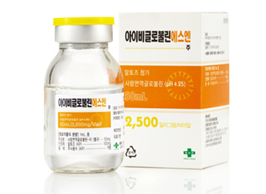  I.V.-Globulin SN inj. Including high purity IgG immune function improved formulation | 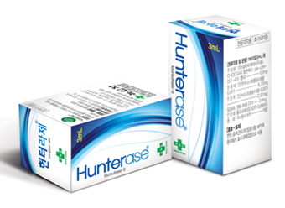Hunterase (Hunter syndrome drug) | 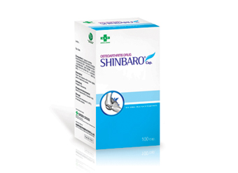Shinbaro : For the treatment(Enzyme Replacement Therapy) of Hunter syndrome (Mucopolysaccharidosis II)
Shinbaro (Osteoarthritis) | 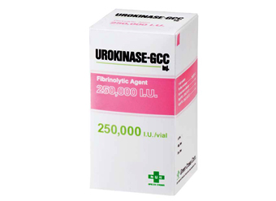Urokinase-GCC inj. Cerebral | 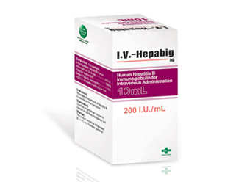I.V. Hepabig inj.
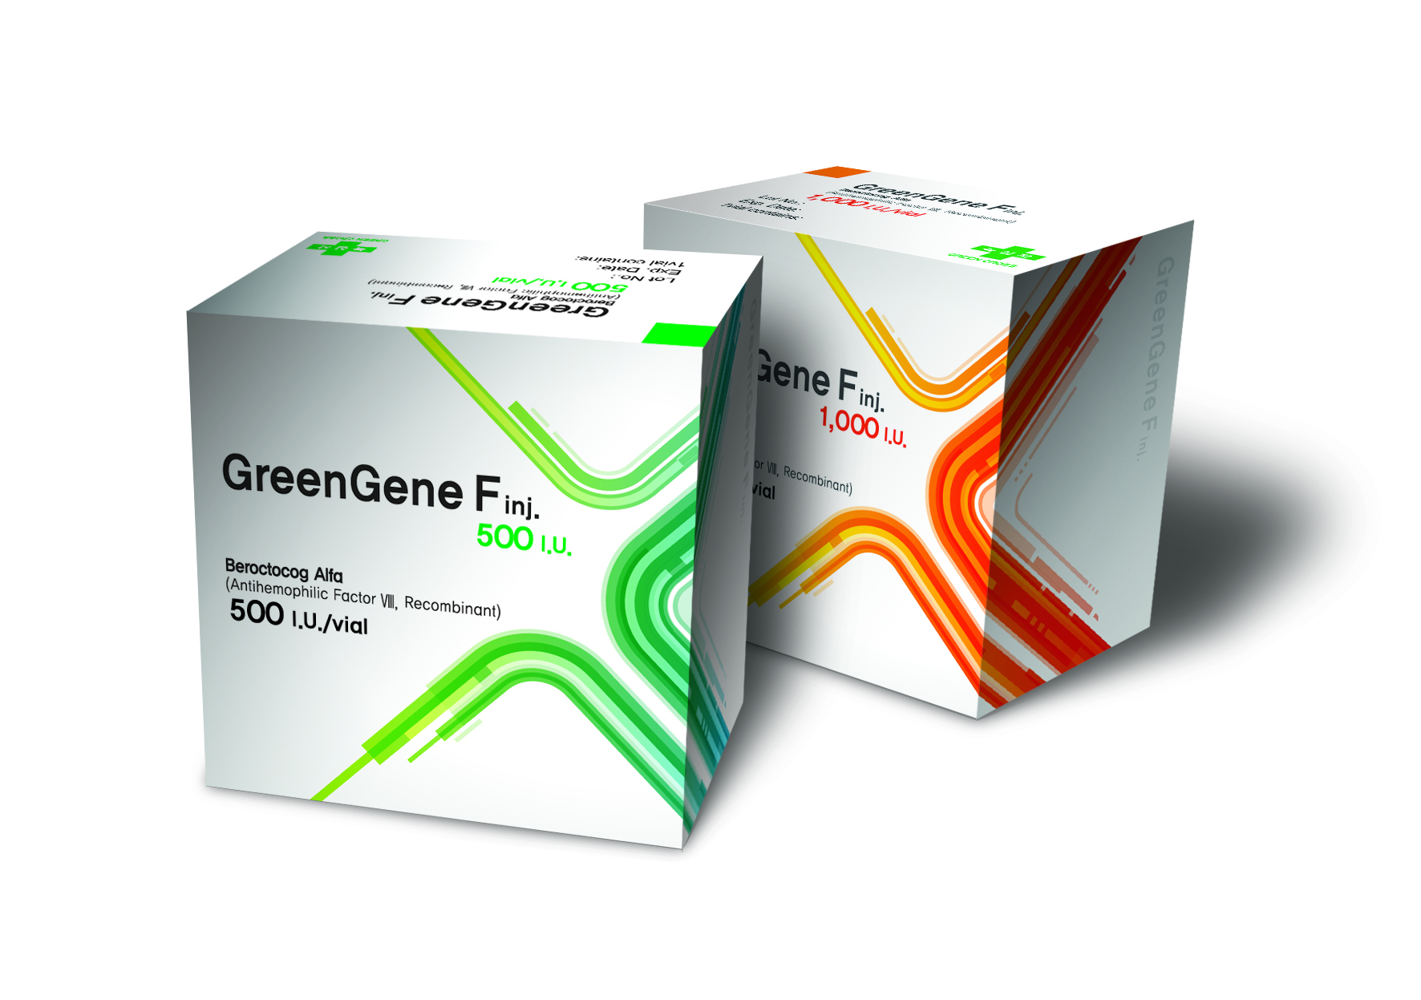GreenGene F inj. 500I.U. Hemophilia A patients with bleeding symptom control and hemostasis | 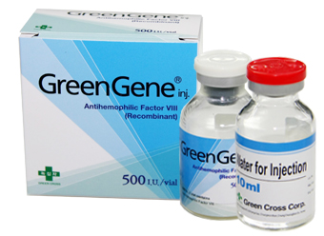Green Gene inj. Hemophilia A patients with drug | 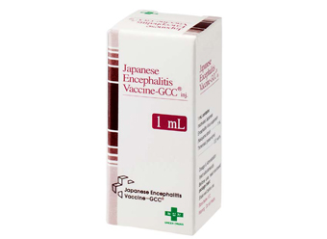Japanese Encephalitis Vaccine-GCC inj. Prevention of Japanese encephalitis
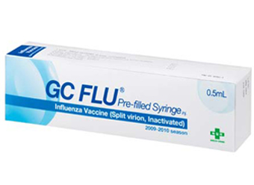  GC FLU pre-filled syringe inj. Prevention of influenza (flu) | 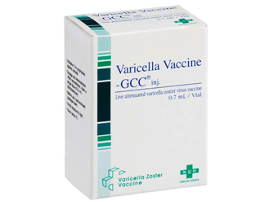Varicella Vaccine-GCC inj. For prophylaxis of Varicella | 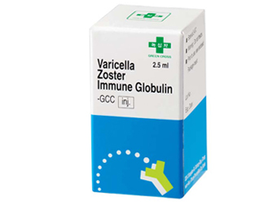Varicella-Zoster Immune Globulin-GCC inj. Passive immunization against chickenpox formulation
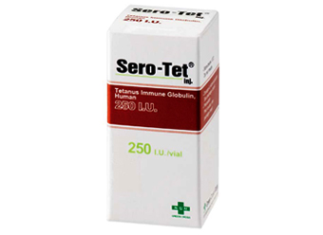  Sero-Tet Circulation Authority Executive Summary | 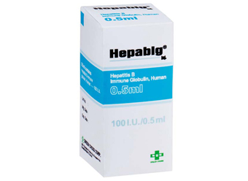Hepabig inj. Hepatitis B vaccination | 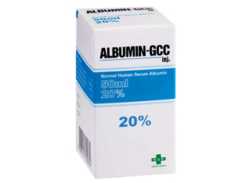Albumin inj. 20%-GCC: Hypoalbuminemia drug

◦ Company Milestones

Year
1971 | Produced the nation’s first plasma fractionation droduct.
1983 | Developed Hepavax B, the world’s 3rd Hepatitis B vaccine.
1990 | Established the Korea Hemophilia Foundation.
1993 | Developed the world’s 2nd varicella vaccine.
1995 | Established Green Cross China.
2008 | Developed GreenGene, the world’s 4th recombinant Factor Ⅶ for hemophilia A.
2009 | Established Green Cross America(GCAM).
2012 | Developed Hunterase, the world’s 2nd treatment for Hunter syndrome.
2013 | Signed a contract with the Thai Red Cross for plasma fractionation plant project.

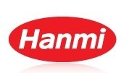

Established in 1973 in Korea, Hanmi Pharmaceuticals now is one of the top 5 pharmaceutical companies in terms of revenue, and the most R&D focused company with the highest R&D investment for several years.

Hanmi has been successful for a few decades with high flexibility, continuously changing its market/development strategy from first generics to IMD & FDC (Incrementally Modified Drug and Fixed Dose Combination) to new drug development including innovative small molecules and biologics. During the period of significant changes, Hanmi made multiple strategic collaboration relationships with multinational companies and biotech companies.

Based on the success in 1980s and 1990s, Hanmi started its Chinese operation in 1996 with establishment of Beijing Hanmi. Now, Beijing Hanmi grew as a well-localized and well-settled Chinese company with more than 1,300 staffs including R&D, sales / marketing, and manufacturing experts and significant growth rate higher than 20% every year. Currently, Hanmi and Beijing Hanmi is closely collaborating on various business opportunities and new drug development projects as well as sales and marketing in Chinese territories.
As the only Asian company with significant presence both in Korea and China, as the most R&D focused company with number of clinical stage projects with competitiveness, and as the company with open innovation based on multiple development/marketing collaborations, Hanmi is trying to develop and provide differentiated treatment options to patients suffering from various disease.

No. | Classification | Bio, Synthesis | The Name of Products | Main Ingredient | Use (Indications) | Formulation
1 | IMD (Combination) | Synthesis | Amosartan | Amlodipine/Losartan | Anti-hypertensive | Tab.
2 | IMD | Synthesis | Amodipin | Amlodipine camsylate | Anti-hypertensive | Tab.
3 | IMD | Synthesis | Esomezol | Esomeprazole Sr | Anti-ulcer | Tab.
4 | Generic | Synthesis | Pidogul | Clopidogrel napadisilate | Anti-platelet | Tab.
5 | IMD | Synthesis | Potastine OD | Bepotastine Ca | Anti-allergy | Tab.

No | The Name of Technology | Main Ingredient | Use (Indications) | The Stage of  Development
1 | HM11260C | LAPS-Exendin | Long-acting Exendin-4 analog | Phase Ⅱ
2 | HM10560A | LAPS-hGH | Long-acting hGH | Phase Ⅱ
3 | HM10460A | LAPS-GCSF | Long-acting G-CSF analog | Phase Ⅱ
4 | HM10760A | LAPS-EPO | Long-acting EPO | Phase I
5 | HM10660A | LAPS-IFNα | Long-acting IFNα | Phase Ⅱ
6 | HM12460A | LAPS-Insulin | Long-acting Insulin | Phase I
7 | Oraxol | Paclitaxel +HM30181A | Anti cancer | Phase Ⅱ
8 | Oratecan | Irinotecan + HM30181A | Anti cancer | Phase I
9 | HM781-36B | - | Orally active pan-Her inhibitor | Phase Ⅱ
10 | KX2-391 | - | Src tyrosine kinase and tubulin polymerization inhibitor | Phase I
Foundation Date | 1973. 6. 15 (Spin off on 2010. 7. 5)
President & CEO | Sung-Ki Lim, Gwan-Sun Lee
Total Sales | 674 billion won (2012) / R&D Investment : 91 billion won (2012)(K-IFRS)
Employee | 1,733 (2012)
Subsidiaries Company | Hanmi Fine Chemical, Beijing Hanmi Pharm
Holding Company | Hanmi Science Co., Ltd.

 | Kolon Life Science
Top Leading Global API Manufacturer

Kolon Life Science (KLS) is a subsidiary of Kolon Group, one of top 30 conglomerates in Korea.
KLS manufactures high quality performance active pharmaceutical ingredients (APIs) and advanced intermediates with wide range portfolio.
Our most important principle in our business partnerships is trustworthiness, which is implemented through a stable supply and on-time delivery. Currently, we are recognized as the #1 Korean API supplier in Japanese market, expanding our reach to EU and US market as well.

API Plants in compliance with GMP Regulation

KLS has two manufacturing facilities in Korea, one in Chungju and the other in Eumsoung, which have been successfully approved by the Korean FDA, EMA and Japanese PMDA. Chungju facility is the newest and largest cGMP compliant site with over 700 metric tons of capacity.
The versatile technology is used to design, develop and optimize process qualifications, process validations and production scale-ups ranging from kilograms to multi-tons for commercial use. KLS also offers ICH stability studies and complete documentations including drug master files in CTD format.

CMO, CMS and HP APIs

KLS provides custom synthesis development and manufacturing services for pharma companies worldwide. As such, we have coordinated our own integration of R&D, production, and distribution lines. Our highly qualified resources and experiences are all prepared and available for the third-party use.
Also, we are taking a proactive approach to develop and manufacture High Potency APIs, including APIs for Anticancer, through which we will open a path of increasing business opportunities of CMO and CMS for new drugs.

 | Contact Information
 | Park, Chang-Yong |  | 82-10-5789-1991 |  | cyp1991@kolon.com
 | Product List for PDP Partnering
Commercialized APIs
NSAIDs |  | Felbinac, Flurbiprofen, Ketoprofen, Loxoprofen Na, Zaltoprofen
Circulatory System |  | Argatroban Hydrate, Azilsartan, Candesartan Cilexetil, Dabigatran Etexilate Mesilate, Ezetimibe, Irbesartan, Losartan Potassium, Olmesartan Medoxomil, Pitavastatin Ca, Rosuvastatin Ca, Simvastatin, Valsartan
Anti-infective |  | Famciclovir, Garenoxacin Mesilate Hydrate, Levofloxacin, Nadifloxacin
CNS |  | Donepezil HCl, Duloxetine HCl, Mirtazapine, Olanzapine, Pregabalin, Sumatriptan Succinate
Others |  | Bazedoxifene Acetate, Dasatinib Hydrate, Deferasirox, Erlotinib HCl, Fexofenadine HCl, Gefitinib, Imidafenacin, Linagliptin, Minodronic Acid Hydrate, Mirabegron, Nilotinib HCl Hydrate, Olopatadine HCl, Raloxifene HCl, Silodosin, Sitagliptin Phosphate Hydrate, Sofalcone, Solifenacin Succinate,  Sorafenib Tosilate, Sunitinib Malate, Varenicline Tartrate, Voglibose, Zea Mays L. Extract

 | MediPost
MEDIPOST has dedicated its focus on biotechnology from its foundation in year 2000 until today, in spite of numerous adversities, rises and falls within the stem cell area.
As a result, MEDIPOST has become a frontrunner in the field of the biopharmaceuticals not only in Korea but also in the world. MEDIPOST with its state-of-the-art platform technology has led to the development and approval of the world’s first allogeneic stem cell therapy product – CARTISTEM®.
Biotechnology is considered to be the new growth engine to lead the future economy of Korea. In particular, stem cell-based therapeutics is considered to be the most pivotal cutting-edge industry area.
MEDIPOST recognizes the national and public expectations in the field both from within Korea and abroad, and continue to drive our efforts to achieve breakthroughs for the treatment of intractable diseases through stem cells.
MEDIPOST continues its endeavors on clinical development and commercialization of stem cell therapeutics to improve quality of lives of many patients with intractable diseases not only in Korea, but also around the globe.

Main Products
CARTISTEM® |  | Stem Cell Drug, based on allogeneic umbilical cord blood derived from mesenchymal stem cells. It aims at treating knee cartilage defects of OA patients caused by degeneration or repeated trauma.
NEUROSTEM® |  | Stem Cell Drug, based on mesenchymal stem cells derived from allogeneic umbilical cord blood that is being developed to treat Alzheimer’s type dementia.
PNEUMOSTEM® |  | Stem Cell Drug, based on mesenchymal stem cells derived from allogeneic umbilical cord blood that is being developed to treat bronchopulmonary dysplasia of premature babies.

 | Macrogen
The first message to mankind at the dawn of the 21st century was the completion of the map of the human genome. The Human Genome Project, an attempt to discover the entire human genomic structure, has allowed new approaches to biological phenomena, along with the fact that the secrets of life are informationized. These accomplishments that humankind has achieved contribute to a new paradigm, information medicine, which means that the era of customized individual medicine and remote medical service has already begun, based on human genome information and bioinformatics.
In order to complete the medical revolution of the 21stcentury, characterized by regenerative and informatic medicine, supporting tools are indispensable. In the light of this, Macrogen Inc. has developed and commercialized basic tools for genome medicine - from genetic information analysis to functional genomics - by using bioinformatics infrastructure. Moreover, with continuous R&D on genomics, Macrogen Inc. has been able to broaden the range of genomics industry by inventing 'Super Alcohol Bacteria' and a congenital-hereditary-disease diagnosing kit. Furthermore, Macrogen Inc. has not only commercialized genetically engineered mice production and cloning technology, but has also challenged xenotransplant industry by establishing MGenbio Inc.
"Sharply but Sincerely" (with a keen eye and prudence), all staff of Macrogen Inc. are being encouraged by the infinite vision of bioindustry and feel great responsibilities as members of one of the leading companies in bioindustry.Based on steady R&D, increasing business efficiency, and clear corporate ethics, we, Macrogen Inc., will become a role model for biotech companies, which puts it in a strong position to maximize the profit of shareholders and the benefits for communities..
Business Divisions
Sequencing |  | With excellent research staffs and nation’s best experts, Macrogen provides distinguishing services to many researchers around the world. Macrogen’s dedication to research keeps produces successful completion in large projects such as Korea Genome BAC Clone Map and Zymomonas mobilis Genome Project.
Oligo |  | Macrogen Inc. provides all our valued customers with Oligo Synthesis service supported by the state of the art machinery and perfected LIMS system. Our very own MOPCTM purification method that does not fall behind PAGE of HPLC purification method is included as a basic material of Oligo Synthesis service. All data are reviewed through MALDI-TOF to guarantee you the quality that may fulfill all standards.
Microarray |  | As the first company having introduced Oligochip products in Korea, Macrogen has been developing and providing Microarray total solution to many customers all around the world. Macrogen develops and sells various product lines such as MacArray™ Express Oligochip capable of identifying the degree of gene expression and MacArray™ Karyo capable of diagnosing human chromosome aberration, using microbes, mice, and human tissue samples. In addition, the company designs and produces MacProbe™ consisting of various FISH Probe products.
Transgenic & Knockout Mouse |  | Macrogen, based on several years of experiences and technologies accumulated from Seoul National University Transgenic Research Institute, its predecessor, has established world-class transgenic and gene knockout technologies and services. With advanced SPF facility newly set up, Macrogen is focusing on functional genomics research while providing transgenic/knockout mice covering the entire process ranging from vector design to delivery.
Bioinformatics |  | With Korea’s largest gene database with its world-recognized core competences, Macrogen has obtained excellent results in the field of Bioinformatics. Furthermore, with excellent BT & IT human resources at Bioinformatics Research Center, Macrogen provides a total of 6 services including database construction, Genome Research, and Bioinformatics comprehensive analysis system consulting services.

ViroMed
ViroMed Co., Ltd. is a leading biotechnology company with a mission to discover and develop innovative biopharmaceuticals for human diseases. ViroMed’s numerous achievements since its inception demonstrate that it is one of the most scientifically advanced R&D companies in today’s global biopharmaceutical industry. The company has differentiated itself from competitors with its core technology and seasoned management.

ViroMed is headquartered in Seoul, Korea with a US presence in the Atlanta area. The company has assembled a diverse pipeline of novel biologics and herbal therapeutics in the areas of cardiovascular disease, cancer, and immune disorder, with multiple clinical studies ongoing in the US, Korea, and China. ViroMed is publicly held with a listing on the KOSDAQ stock exchange (084990).
Pipeline
ViroMed focuses on two areas - DNA/protein-based biopharmaceuticals and phytotherapeutics
Our major biopharmaceutical targets are cardiovascular disease and cancer.

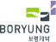

Company | Boryung Pharmaceutical Co. Ltd.
Representative | Tae-hong Choi | E-mail
Hompage | http://www.boryung.co.kr
Address | Boryung Bldg, 136, Changgyeonggung-ro, Chongro-ku, Seoul 110-750, Korea
Research Institute Address | Neunganro 17, Danwon-gu, Ansan-si, Gyeonggi-do, Korea
Year of Establishment | 1963 | Sales (‘14) | KRW 359,491 Million
The Number of Employees (‘15) | Total | The Number of Researcher (‘15) | Total
 | 1112 |  | 115
Contact Person | Edward Kim | Contact Phone | 02-708-8174
Contact E-mail | edward.kim@boryung.co.kr | Contact Fax | 02-708-8439
Introduction of Company
Boryung Pharmaceutical company (here after Boryung), since founded in 1963, has been trying its best to contribute to the health and well-being of humanity with corporate mission to 'realize mutual health and co-prosperity based on human centered values'.
Boryung has invested continually on research and development and made continuous efforts to produce high-quality products in the specialty areas such as cardiovascular, antineoplastic and antibiotics drugs. As a result, our products such as Gelfos M, Yongkaksan and Kyushin have become the best selling products and Boryung has emerged as the most familiar and trusted brand in Korea.
Boryung has developed KanarbⓇ by our proprietary technology. Kanarb is an innovative anti-hypertensive drug that has been approved by the KFDA as the 15th new drug in 2011, also it is 8th new ARB in the world. It was also awarded with ‘Korea Technology Awards’ by the Ministry of Knowledge Economy and ‘Oh Song New Drug Prize’ by the KFDA in 2011. Kanarb is the best selling ARB in Korea and has USD 30 million sales in 2014.
Until now, Boryung has successfully licensed-out KanarbⓇ with Mexico and 12 other Latin countries, Brazil, Russia and China and launched in Mexico September of last year. Also we are under business licensing discussions with Japan, USA, Europe, Australia etc.

No. | Classification | (Bio, Synthesis) | The Name of Products | Main Ingredient | Use (Indications) | Formulation
1 | New Product | Synthesis | Kanarb | Fimasartan Potassium | essential hypertension | Tablet
2 | Generic | Synthesis | Gelfos | Aluminum phosphate, colloid | stomach ulcer | Suspention
3 | Generic | Synthesis | Astrix | Aspirin | myocardial infarction | Capsule
4 | Generic | Synthesis | Stogar | Lafutidine | stomach ulcer | Tablet
5 | Generic | Synthesis | Tamsulosin | Tamsrocin HCl | Benign Prostate hypertrophy (BPH) | Capsule
6 | Generic | Synthesis | Rebamipide | Rebamipide | gastric ulcer | Tablet
7 | Generic | Synthesis | Br-Glimepiride | Glimepiride | Type -II diabetes | Tablet
8 | Generic | Synthesis | Nafcillin | Nafcillin sodium | beta-lactamase | Injection
9 | Generic | Synthesis | Megace | Megestrol | anorexia due to AIDS/ cancer | Suspention
10 | Generic | Synthesis | Rinoebastel | Ebastin, pseudoephedrine | chronic rhinitis | Capsule
11 | Generic | Synthesis | Maxnophen | Tramadol HCl | chronic pain | Tablet/ Semi tablet
12 | Generic | Synthesis | Neomedicough | Dihydrocodeine tartrate | cough/ sputum | Tablet
13 | Generic | Synthesis | Cresante | Rosuvastatin | hyperglicemia | Tablet
14 | Generic | Synthesis | Itraconazol | Itraconazole | candida vaginitis | Tablet
15 | Generic | Synthesis | Cinalong | Clinidipine | essential hypertension | Tablet
16 | Generic | Synthesis | Netilmcin | Netilmicin sulfate | Cefatamet pivoxil | Injection
17 | Generic | Synthesis | Meiact | Cefditoren pivoxil | infectious disease | Granule
18 | Generic | Synthesis | Taxol | paclitaxel | cancer | Injection

No | Classification | Bio/ Synthesis | The Name of Technology | Main Ingredient | Use (Indications) | The Duration of Development | The Stage ofDevelopment
1 | IMD | Synthesis | Development of ARB combination + CCB | Fimasartan + Amlodipine | Anti hypertensive | 2008 07 ~  2015. 05  on going | Clinical Trials  in process
2 | IMD | Synthesis | Development of ARB combination + Statin | Fimasartan + Rosuvastatin | Anti hypertensive, Antihyperlipidemia | 2015. 05  on going | Clinical Trials  in process
3 | IMD | Synthesis | Development of ARB combination + CCB + Statin | Fimasartan + Amlodipine + Rosuvastatin | Anti hypertensive, Antihyperlipidemia | 2015. 05  on going | Clinical Trials  in process
4 | IMD | Synthesis | Development of ARB combination + Statin | Fimasartan + Atorvastatin | Anti hypertensive, Antihyperlipidemia | 2015. 05  on going | Clinical Trials  in process
5 | NBE | Bio | Development of New gene therapy | - | Antitumor | 2013. 12~  2015. 05on going | Clinical Trials  in process
Producst Name | Active Ingredient | Indication | Categories | Expected Country | Note
Kanarb | Fimasartan | Hypertension | ETC | Global | out-licensing to Mexico, Brazil, China, Russia
Kanarb plus | Fimasartan, Hydrochlorothiazide | Hypertension | ETC | Global
Kanarb combination | Fimasartan, Amlodipine | Hypertension | ETC | Global | Clinical trials in process
Kanarb combination | Fimasartan, Rosuvastatin | Hypertension, Hyperlipidemia | ETC | Global | Clinical trials in process
Kanarb combination | Fimasartan, Amlodipine, Rosuvastatin | Hypertension, Hyperlipidemia | ETC | Global | Clinical trials in process
Kanarb combination | Fimasartan, Atorvastatin | Hypertension, Hyperlipidemia | ETC | Global | Clinical trials in process
ADmycin | Doxorubicin | Antineoplastics | ETC | Global
Oxalitin | Oxaliplatin | Antineoplastics | ETC | Global
Gelfos | Colloidal Aluminum Phospate | Gastric Hyperacidity  Heartburn | OTC | Global
Stogar | Lafutidine | Gastric ulcer | ETC | Global
Cinalong | Cilnidipine | Essential Hypertension | ETC | Global

Producst Name | Active Ingredient | Dosage form | Indication | International Certification
Oxalitin 50mg/100mg | Oxaliplatin | Injection | Antineoplatics | Pakistan MOH
Inoxel 30mg/100mg/150mg | Paclitaxel | Injection | Antineoplatics | Pakistan MOH
Modakemin 0.5g/1g | Ceftazidime | Injection | Anti-infection | PMDA
Riasophin 0.5g/1g | Ceftriaxone sodium | Injection | Anti-infection | PMDA
Kemisporin 0.25g/0.5g/1g | Cefotiam HCl | Injection | Anti-infection | PMDA
Cepfirome 0.5g/1g | Cepfirome sulfate | Injection | Anti-infection | PMDA
Rokilide 150mg | Roxithromycin | Oral | Anti-infection | PMDA
Cefaclor capsule 250mg | Cefaclor | Oral | Anti-infection | PMDA
Fosfomycin 0.5g/1g/2g | Fosfomycin | Injection | Anti-infection | PMDA
Fluconazole capsule  50mg/100mg | Fluconazole | Oral | Anti-infection | PMDA
Cefon1g | Cefoperazone | Injection | Anti-infection | PMDA
Fexofenadine | Fexofenadine | API | Anti-Allergy | PMDA
Pitavastatin | Pitavastatin | API | Hyperlipedemia | PMDA
Fimasartan | Fimasratan | API | Hypertension | COFEPRIS / Invima

